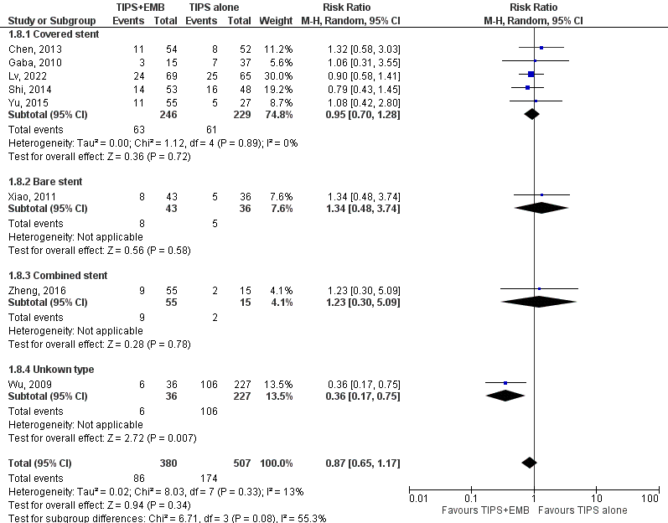

Supple 4. Forest plots of meta-analyses comparing the incidence of mortality between the TIPS alone groups and TIPS combined with variceal embolization group ( TIPS +EMB) based on stent types ( covered vs. bare vs. combined vs. unknown).

