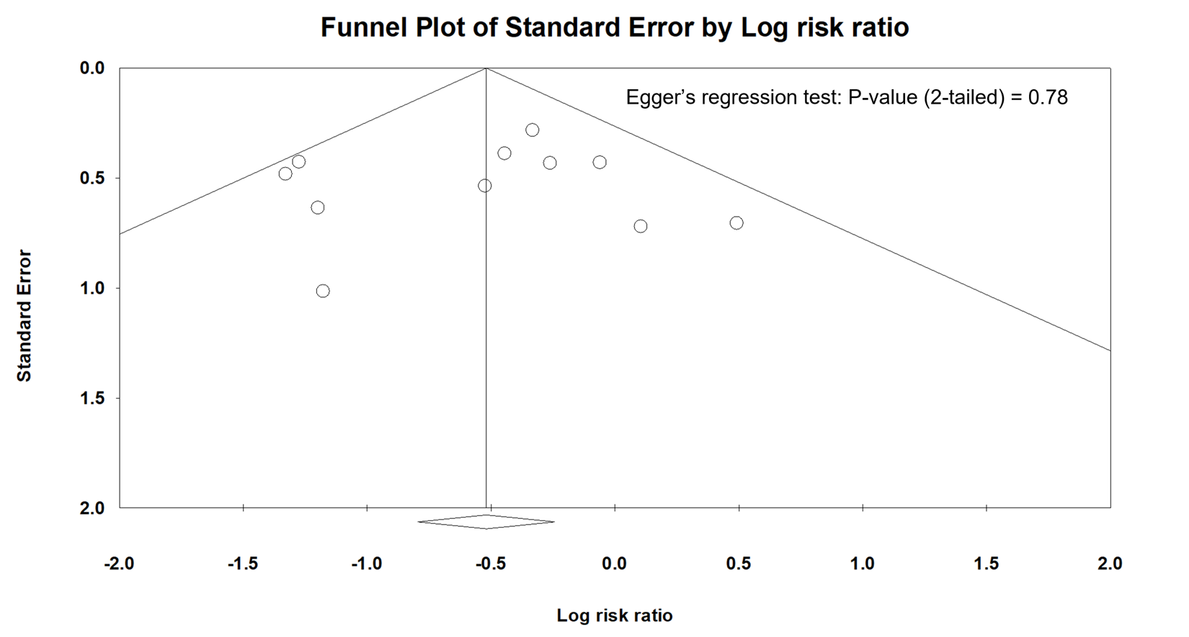

Supple 7. Funnel plot for the primary outcome (rebleeding).

