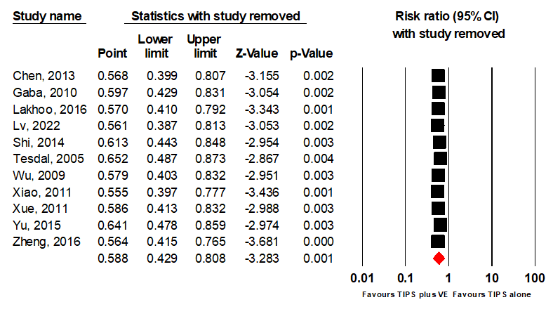

Supple 1. Leave-one-out sensitivity analysis for studies comparing variceal rebleeding between the TIPS alone groups and TIPS combined with variceal embolization group.

