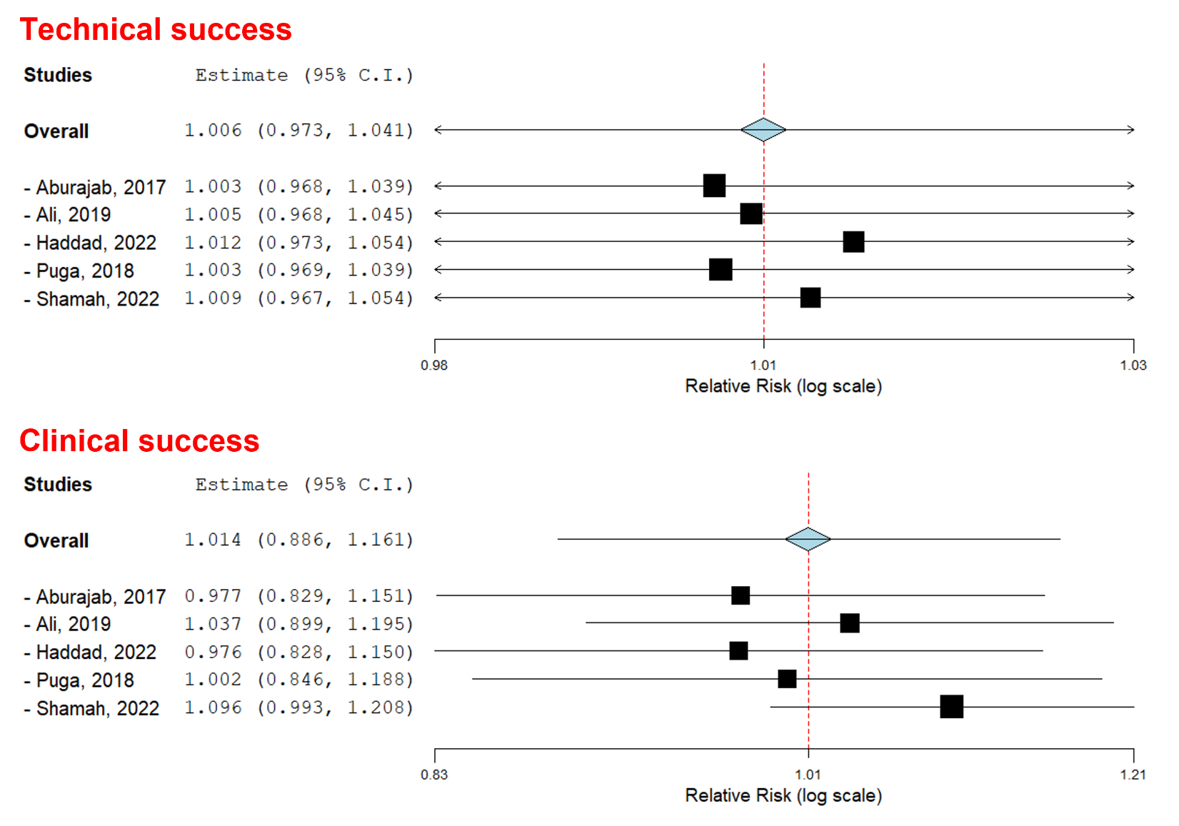
Suppl 2. Leave-one-out sensitivity analysis for technical success and clinical success.

